Transport Management Plan

INTRODUCTION

The objective of this Transport Management Plan (TMP) is to assess and manage traffic and transport in and around the Peninsula Recreation Precinct. The proposal is for a single day event (Coastal Twist) on an ongoing basis each year on the 1st of October (this will ensure we can run the event, any day of the month of October) for the annual Coastal Twist Fair Day. This TMP details activities in place for a safe and successful event by:
- Complying with the requirements of the Work Health Safety Act 2011
- Detailing a Traffic Guidance Scheme (Appendix 1).

EVENT DETAILS
Event | Coastal Twist Fair Day
Location - offsite | Peninsula Recreation Precinct, Sydney Avenue, Umina Beach
Date | Sunday 1st October
Event start time | 10am
Event finish time | 5pm
Event set up start time | 6am
Event pack down finish time | 7pm

EVENT CONTACT DETAILS
Organisation | Coastal Twist Festival
ABN | 799 788 41089
Contact name | Juan Iocco
Role | Co-Chair
Mobile | 0416 225 625
Phone | 02 4314 6004
Email | festival@coastaltwist.org.au
Webpage | Coastaltwist.org.au

EVENT OVERVIEW
The Coastal Twist Fair Day is the Coastal Twist Festival’s centrepiece, the biggest and most colourful all ages event of the festival. This free vibrant and fun event is where absolutely everyone from near and afar come together to celebrate humanity and connection in a fun and culturally rich day of Art, Entertainment, Food, Shopping and Pets with a mass outdoor picnic. The event sees upto 5,000 locals, visitors, kids, pooches, families, friends hit the Peninsula Recreation Precinct, Umina Beach.

EMERGENCY CONTACTS
ROLE | CONTACT | PHONE
Coastal Twist Fair Day operations | Jess McLeod  Juan Iocco | 0402 733 797  0416 225 625
Coastal Twist Traffic Control | TBC
Coastal Twist Security | TBC
Coastal Twist Police paid per user | TBC
Coastal Twist First Aid | St Johns Ambulance | TBC
Police – Woy Woy |  | 02 4379 7399
Ambulance |  | 000
Gosford Hospital |  | 02 4320 2111
Fire Brigade Umina |  | 02 4337 9740
Central Coast Council  - Traffic  - Waste  - Water |  | 02 4306 7900  TBC  TBC  TBC
NSW Rural Fire Service |  | 1800 679 737
State Emergency Service (SES) |  | 132 500
Power (Ausgrid) |  | 13 13 88
QLife | 3pm to midnight, everyday | 1800 184 527
Mental Health Line (Central Coast) |  | 1800 011 511

EVENT CLASSIFICATION
As per the NSW Government’s Guide to Traffic & Transport Management for Special Events Version 4.1, dated Nov 2025 – the class of Special Event for the Coastal Twist Fair Day is Class 3/4.
Class 2 is classified as an event that has moderate impact on the traffic and transport network, causing moderate disruption to the non-event community.

PUBLIC LIABILITY INSURANCE
The event is fully covered by Public Liability Insurance to the value of $20,000,000. Please see Appendix 2 for Certificate of Currency.

TRANSPORT RISK MANAGEMENT ASSESSMENT
Hazard | Likelihood | Consequence | Risk | Prevention / response | Person responsible | New risk assessment
- Traffic incident (pedestrian or vehicle) | Possible | Major | High | Traffic Management contractor engaged at Sydney Avenue entrance to manage traffic flow. Volunteer support at pedestrian crossing. 10km/h zone. | Event organiser and Traffic Management contractor | Low
- Volunteer, contractor, artist, stallholder involved in incident | Possible | Major | High | Traffic Management contractor engaged at Sydney Avenue entrance to manage traffic flow. Volunteers, contractors, artists and stallholders briefed on safety | Event organiser | Low
- Industrial action with bus or trains | Possible | Moderate | Medium | Event organiser to monitor Transport for NSW webpage and/or media for potential industrial action. | Event organiser | Low
- Impact to bus services | Possible | Moderate | Medium | Event organiser to brief Busways on event. | Event organiser | Low
- Impact to train services | Possible | Moderate | Medium | Event organiser to brief Transport for NSW on event. In most cases, replacement buses are deployed. | Event organiser | Low
- Impact to ferry services | Possible | Moderate | Medium | Ferry is contingent on weather. | Event organiser | Low
- Emergency services requiring access to Caravan Park | Possible | Moderate | Medium | Emergency services briefed. Event organiser to share event contact and traffic control contact details with Caravan Park | Event organiser | Medium
- Emergency services requiring access to Surf Club | Possible | Moderate | Medium | Emergency services briefed. Event organiser to share traffic control contact details with Surf Club | Event organiser | Medium
- Traffic in and out of Caravan Park | Likely | Moderate | High | Traffic control contractors engaged to manage traffic flow of vehicles in and out of Caravan Park | Event organiser and Traffic Management | Low
- Major vehicle incident nearby | Possible | Moderate | Medium | Police user pays on site and can coordinate with Police on patrol / at incident if required | NSW Police | Low
- Access for garbage trucks | Likely | Minor | Medium | Traffic control contractors engaged and will support access requirements for garbage trucks | Event organiser and Traffic Management | Low
- Vehicle / pedestrian incident during bump in and bump out | Possible | Major | High | Stallholders and contractors briefed in advance of vehicle and pedestrian requirements for bump in and out. Traffic control contractors on site to support. | Event organiser and Traffic Management contractor | Low
- Lack of accessibility access | Unlikely | Moderate | Medium | Event organiser and volunteers will monitor footpaths to ensure no blockages to access. Disability parking spaces available in Surf Club carpark. | Event organiser | Low
- Incident at pedestrian crossing | Possible | Major | High | Two pedestrian crossings at site and traffic controllers will be stationed at the first crossing. Festival volunteers will be stationed at second crossing. | Event organiser and Traffic Management contractor | Low
- Traffic Management contractor no show | Possible | Moderate | Medium | Event organiser to confirm attendance (including start time and event contact) and regularly engage in the lead up to event. | Event organiser | Low

Risk assessment key
Likelihood | Description |  | Consequence | Description
Almost certain | The incident is expected to occur at least once during the festival |  | Catastrophic | Core functions are unable to be delivered
Likely | The incident will probably occur during the festival |  | Major | Delivery of core functions is severely reduced
Possible | The incident might occur during the festival |  | Moderate | Delivery of core functions is reduced
Unlikely | The incident is unlikely to occur during the festival |  | Minor | Limited reduction in delivery of core functions
Rare | The incident could occur during the festival in exceptional circumstances |  | Insignificant | Delivery of core functions is unaffected or within normal parameters

Operational risk matrix by level of consequence
Likelihood | Insignificant | Minor | Moderate | Major | Catastrophic
Almost certain | Medium | Medium | High | Extreme | Extreme
Likely | Medium | Medium | High | Extreme | Extreme
Possible | Low | Medium | Medium | High | Extreme
Unlikely | Low | Low | Medium | High | High
Rare | Low | Low | Medium | Medium | High

ENGAGEMENT WITH EMERGENCY SERVICES

NSW Police
Engagement with NSW Police Brisbane Water district is collaborative and continuous.

NSW Ambulance
NSW Ambulance will be briefed via email (ambulance-eventplanning@health.nsw.gov.au).

NSW Fire Brigade
NSW Fire Brigade will be briefed via email.

ENGAGEMENT WITH TRANSPORT OPERATORS

Transport for NSW
Transport for NSW and NSW TrainLink will be briefed via email.

Busways
Busways (controllergosford@busways.com.au) will be briefed via email.

Fantasea Ferry
Fantasea (palm.beach@fantasea.com.au) will be briefed and email.

Central Coast Taxis
Central Coast Taxis (fax@cctaxis.com.au) will be briefed and email.

UMINA BEACH PUBLIC TRANSPORT OPTIONS
Peninsular Recreation Precinct
Ocean Beach Surf Club
Mingaletta
TRAIN | Woy Woy Train Station  Trains from Central to Woy Woy leave approx. every 30min on weekends and public holidays.  Trains from Newcastle to Woy Woy leave each hour on weekends and public holidays.  Central Coast & Newcastle Line Route and Timetable
BUS | Bus 50 (Woy Woy to Umina via Ocean Beach Road)  Woy Woy Train Station, Stand B (Stop ID 225613)  Umina Beach Public School, Hobart Ave (Stop ID 225796) – 5-minute walk to Fair Day  Bus 50 Route and Timetable  Bus 54 (Woy Woy to Pearl Beach and Patonga via Umina Beach)  Woy Woy Train Station, Stand E (Stop ID 225616)  Umina Beach Public School, Hobart Avenue (Stop ID 225796) – 5-minute walk to Fair Day  Bus 54 Route and Timetable  Bus 55 (Ettalong Beach to Gosford via Woy Woy and Umina Beach)  Woy Woy Train Station, Stand A (Stop ID 225612)  West St opp Oscar St (Stop ID 225739) – 10-minute walk to Fair Day  Bus 55 Route and Timetable
FERRY | Palm Beach – Wagstaffe – Ettalong Beach Ferry  Further details on Ferry including timetable
TAXI / RIDE SHARE | Central Coast Taxis – 131 008 (fleet includes wheelchair accessible taxis WAT).  Ride shares operate on the Central Coast, however, are limited.

LOCATION MAP
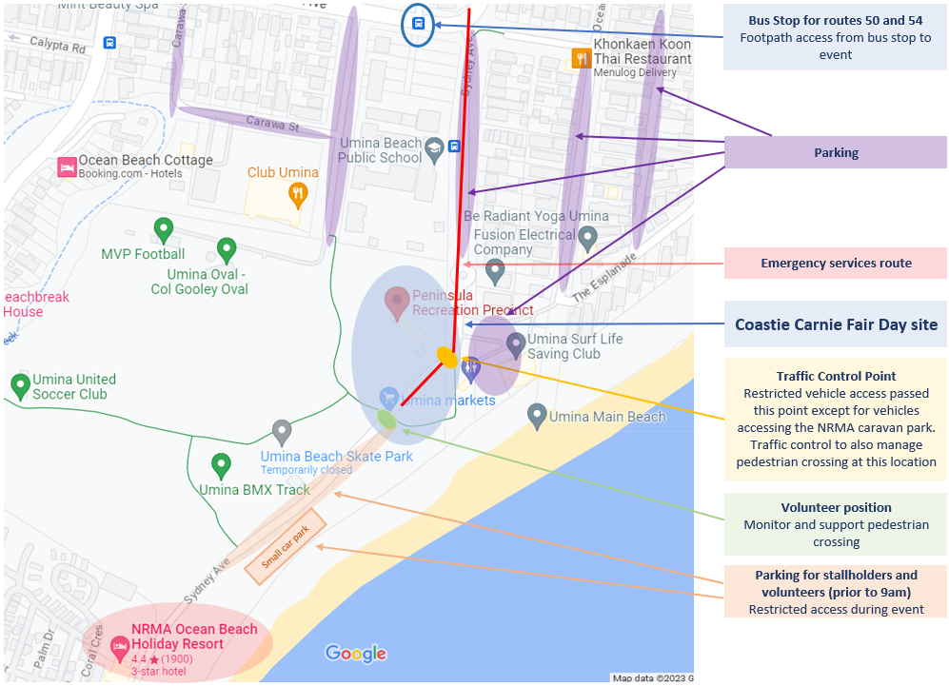

PARKING
Limited spaces in the Umina Beach Surf Life Saving carpark between Ocean Beach Road and Sydney Avenue (carpark has a number of Disability Parking spaces). Street parking in surrounding streets including: Sydney Avenue, Ocean Beach Road, Melbourne Avenue, Carawa Street, Hobart Avenue.
Street parking along Sydney Avenue between the Surf Club and the NRMA Caravan Park will be made available to stallholders and volunteers of the Coastal Twist Fair Day prior to traffic control restrictions put in place (except those vehicles entering in and out of the NRMA Caravan Park).

CONSTRUCTION
There is no current construction activities in the vicinity of the Coastal Twist Fair Day.

TRUSTS, AUTHORITIES OR GOVERNMENT ENTERPRISES
The Coastal Twist Fair Day is using the Central Coast Council’s Peninsula Recreation Precinct and approval from Council is pending.

IMPACT ON PUBLIC TRANSPORT
Public Transport (trains, bus, ferry) will not be impacted as a result of this event. NSW Transport, Busways, Ferry and Central Coast Taxi’s will be briefed ahead of event.

REOPENING OF ROADS AFTER EVENT
No roads will be closed as a result of the Coastal Twist Fair Day. However vehicle restrictions on Sydney Avenue between the Surf Club and NRMA Caravan will be put in place during event. These restrictions will be lifted once at the conclusion of the event and when it is safe for pedestrians and vehicles.

TRAFFIC MANAGEMENT UNQUIE TO THIS EVENT
There are no unique traffic requirements for the Coastal Twist Fair Day.

CONTINGENCY PLANS
Extreme weather: event to be relocated, postponed or cancelled depending on severity.

HEAVY VEHICLE IMPACTS
The Coastal Twist Fair Day is taking in and around local roads and will not have any impact on heavy vehicle routes or movements.

SPECIAL EVENT CLEARWAYS
There are no Special Event clearways required for the Coastal Twist Fair Day.

MINIMISING IMPACT ON NON-EVENT COMMUNITY
This event does not impact the non‐event community either on the main route (or location) or detour routes.

ADVERTISE TRAFFIC MANAGEMENT ARRANGEMENTS
No road closures, restrictions or special event clearways ‐ therefore, no advertising required.

SPECIAL EVENT WARNING SIGNS
This event does not require special event warning signs.

PERMANENT VARIABLE MESSAGE SIGNS
This event does not require permanent Variable Message Signs.

PORTABLE VARIABLE MESSAGE SIGNS
This event does not require portable VMS.

DOCUMENT CONTROL
Version No. | Date | Author | Comments and Key Changes | Approved by
V1.0 | August 2023 | Jessica McLeod
V2.0 | July 2025 | Jessica McLeod
V3.0 | Jun3 2026 | Jessica McLeod

APPENDIX

- TRAFFIC GUIDEANCE SCHEME (being developed by Coast Traffic Solutions)
- PUBLIC LIABILITY INSURANCE – Certificate of Currency

TRAFFIC GUIDEANCE SCHEME: Pedestrian and Vehicle Management
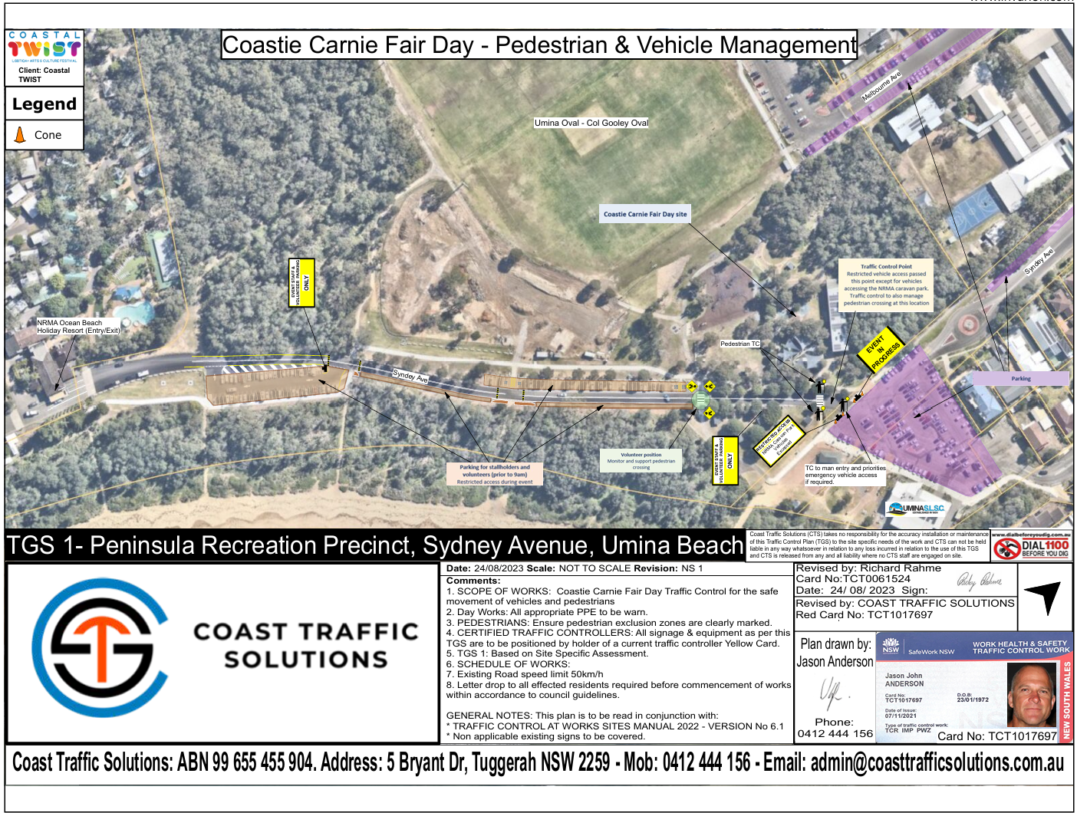

PUBLIC LIABILITY INSURANCE
